HON2120 (2025-2026)
Assignment 1

Please use this file to provide your answers. The test comprises 3 problems and is out of 10 marks.

You may not discuss this assignment with others (apart from the lecturer) before the final submission. You may now work with others in preparing this assignment. The answers should be elaborated by you alone and be in your own words, except for permitted material from sources that are clearly indicated and acknowledged by appropriate references. The use of Artificial Intelligence in connection with this assignment is strictly forbidden. This includes systems such as ChatGPT, Microsoft Copilot, and GPT UiO. You should prioritize the use of concepts and methods covered in the course.

Once completed, your assignment should be uploaded to Canvas. Before uploading, you should add your student ID number to the filename, which will then have this format at the point of submission: HON2120_Assignment_1_2025-2026_000000.docx. Please do not add any identifying information other than your student ID number.

PROBLEM 1 (5 marks)

Read Benjamin L. Curtis’s “To Be Fair” (Analysis, 74:1, 2014, pp. 47-57) and carefully follow the instructions below. Your text should not be longer than 900 words and be an example of analytical writing.

(1) Present in a clear, concise, and effective way the main theses, arguments, assumptions, and conclusions of the article.

(2) Provide a critical assessment of some of the author’s main theses. You should concentrate on the most important and interesting points.

(For (2), you can focus on one or more of the following questions. Are there interesting objections to the author’s main points? Are there some interesting responses to those objections? Can some of the author’s main arguments be improved? Can some of the author’s main views be improved?)

ANSWER

(1)
Benjamin L. Curtis’s “To Be Fair” introduces a theory of fairness, detailing how an agent should act within specifically allocative situations, as in situations where some good is being distributed. He contrasts his theory with another made by John Broome. Curtis boils these situations down into two parts: the good, as in, the thing being distributed, and the claims, as in, the amount each receiving agent (RA) is supposed to get. Curtis then presents The Fairness Claim, a principle which any allocating agent (AA) is to follow when allocating goods, which also comes with a set of steps that he believes solves these situations in the fairest way possible. Curtis agrees with Broome, at least partially, that goods should be distributed proportionally to the claims, but his theory differs in the specifics on how this should be done.

Curtis assumes that there exists some way to determine who has a claim to the good, and that it is irrelevant what the good is, and therefore he does not discuss either of these things. Curtis assumes that there exists some way to determine who has a claim to the goods, and therefore does not discuss this. He also assumes that both goods and claims can be represented by numbers, by some sort of unit, either divisible or indivisible. He also assumes that both goods and claims can be represented by numbers, by some sort of unit, either divisible or indivisible, and that the only thing separating different types of goods is whether a single unit of the good can be divided. Two different divisible goods, for example apples and plots of land, are treated exactly the same by the theory (the same would be true for two indivisible goods).

Curtis argues that the AA must in all situations distribute all of their good, even if this causes the good to be distributed non-proportionally. He writes that any AA should do everything in their power to satisfy the claims, and that this entails using all of the good one has available. As a follow-up to this argument, Curtis argues that giving away the remainder by lottery is not a deviation from fairness, since every party is treated the same within the lottery. This way, even though some parties may become more satisfied than others, the distribution is still fair.

Curtis concludes with his theory, which comes in three steps: 1) If AA can satisfy all claims, do so. 2) If the AA cannot satisfy all claims, claims should be satisfied proportionally, where all claimants receive goods in proportion to their claim. 3) If the total good is not evenly divisible by the claims, and the good isn’t a divisible good, the AA should distribute the good as proportionally as possible, and then the remainder is given away by way of lottery. The probability of a claimant receiving a portion of the remainder is weighted by the ratio between this specific RA’s claim, and the total claim.
Curtis also concludes that his theory of fairness is fairer than the one introduced by John Broome, as it, according to Curtis, treats every equally, which Broome’s theory does not.
3) If the total good is not evenly divisible by the claims, and the good isn’t a divisible good, the AA should distribute the good as proportionally as possible, and then the remainder is given away by way of lottery. The probability of a claimant receiving a portion of the remainder is weighted by the ratio between this specific RA’s claim, and the total claim.
A scenario of this third type could be, for example, dividing three 1$ bills between two RAs, who both have a claim of 2$. Following Curis’ theory, the AA would give each RA 1 bill and distribute the final bill through way of lottery. Since both RAs have a claim to the same amount of money, they would each have a 50% chance of receiving the final bill.
Curtis also concludes that his theory of fairness produces outcomes that are fairer than the one introduced by John Broome, as it, according to Curtis, treats every claimant equally according to the strength of their claim, which Broome’s theory does not.
(2)

To stay within the word limit, I have chosen to remove my first two points, and to dedicate more time to developing my third. I have marked the parts I have removed in red, and the parts I have revised in gray.

Firstly, Curtis’s theory is limited. He even specifies this himself, writing in a footnote: “...the theory is of limited scope.”. This is fine, as the theory never claims to be all-encompassing, but Curtis also assumes that we know the claims beforehand, noting that his theory is “... silent about this...”. Curtis claims to have a theory of fairness, but said theory assumes that we already know what a fair distribution of the good looks like (the claims), meaning that a portion of the work is already done before the theory takes effect. I believe that this portion, deciding what a fair distribution is, is a vital part of what it means to be fair, and that something calling itself a theory of fairness cannot simply assume that it exists.

Secondly, Curtis argues that the AA should distribute all of their good, even if the distribution stops being proportional to the claims, which I disagree with. He writes about the consequence of this himself, noting that “...some claims are satisfied to a greater degree than others...”. If we accept the assumption that the claims are already distributed fairly, then I believe that distributing the good in a way that is not proportional to these claims, that is, deviating from this fair distribution, is not fair.

Then, even if we want to distribute everything, I believe that Curtis’s final situation, situation 8, shows another flaw. I believe that Curtis’s final situation, situation 8, exposes a flaw within his theory. In this situation, the total good is 1999, and we have 1001 claimants, one with a claim of 1000, and 1000 with a claim of 1. Within Curtis’s theory, there is a 50% chance of one of the 1000 claimants getting nothing, and a 50% chance of the one claimant getting 999.
Within Curtis’s theory, there is a 50% chance of one of the 1000 claimants getting nothing, and a 50% chance of the one claimant getting 999. If we assume that a claim is either satisfied or not satisfied, then this way of allocating goods does not deviate from fairness, as no matter which claimant receives the final unit, 1000 of the claimants get their claim fully satisfied. This type of situation could for example be one in which getting your claim satisfied is a matter of life and death. Curtis’ theory maximizes the amount of RAs whose claims are satisfied, meaning we save as many people as possible, and provides a fair process for deciding which of the 1001 claims isn’t satisfied.

Curtis himself specifies that in the first case, a claimant loses 100% of their claim, while in the second case, a claimant only loses 0.1%. I believe then, that it is fairer to choose the second case, as it is closer to the fair distribution, while Curtis’s theory leaves this up to chance.
If we instead look at a situation where it is beneficial for the claimant to have as much of their claim fulfilled as possible, then Curtis’ theory may produce a situation where the goods are distributed unfairly. Looking again at situation 8, Curtis himself specifies that if the claimant with 999 units also receives the final unit from the lottery, one other claimant loses 100% of their claim, while in the other case, where the claimant with 999 units does not receive the final unit, that claimant only loses 0.1%. If the percentage of satisfaction for a given claim directly related to a claimant's quality of life, instead of simply whether or not they live, then staying as close to the proportion of satisfaction detailed by the claims maximizes the total quality of life. The claimant losing 0.1% of their claim loses almost nothing, but the claimant losing 100% loses everything.

Because of this, I believe that Curtis’ theory should handle situations where partial satisfaction of claims is beneficial differently to situations where the only important factor is whether or not the claims are satisfied.

I do however want to mention, that if we wish to go with the lottery-strategy to distribute any indivisible goods, that Curtis’s approach is a good implementation, since it has the odds be weighted by the claims, and guarantees that each claimant can only get a single unit of the good from the lottery above their proportional claim.

PROBLEM 2 (2 mark)

For each of the sentences (a) and (b), do the following.

(1) Identify and describe/display the binary phrase structure tree.

(2) Justify each non-terminal node by explaining the tests you used to identify the constituents.

If there is any syntactic ambiguity, explain it and provide the trees that generate the different readings.

(a) A friend of Lucy stole the big book of poems with a blue cover.

(b) Frank drove the red car in the garage.

ANSWER

(1)
When there are different interpretations of the sentences, they are split into interpretations A and B.

(a)
The sentence “A friend of Lucy stole the big book of poems with a blue cover” can be interpreted in two ways. In interpretation A, there is a book of poems that has a blue cover, which a friend of Lucy has stolen. In the interpretation B, a friend of Lucy has stolen the big book of poems, and used a blue cover as a tool to do so. The following are the binary phrase structure trees for both interpretations:

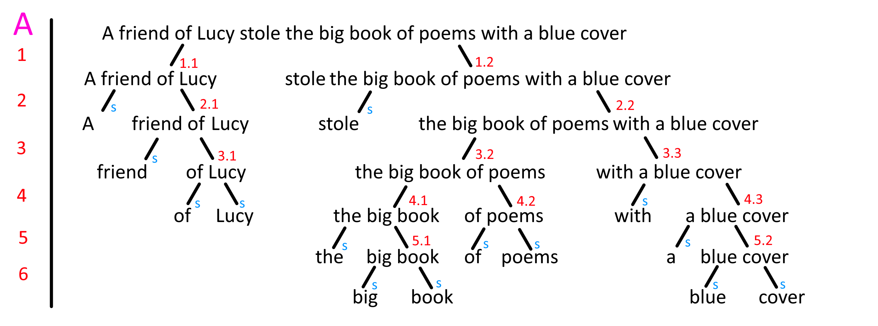
For interpretation A, it has become clear that this tree is incorrect. Seeing how the tree for interpretation B is correct, I believe that the splitting of “the big book of poems with a blue cover” is the place where something goes wrong, specifically connection 3.2, since all other splits also occur in tree B. The following is my attempt at a correct tree:
This does however shift a lot of the indexes down, which makes it difficult to show what has changed without rewriting all of (2), so I will instead list the changes here:

- One new connection has been added: 3.2) “big book of poems with a blue cover” can be replaced by “book”
- The connection that was previously noted as 4.1 no longer exists, since “the” is removed earlier.
All other arguments are still the same (although many have new indexes, which I haven’t rewritten in task (2).
(This is an incredibly messy way of doing this, but I can’t think of an alternative at the moment. Please have mercy on me.)

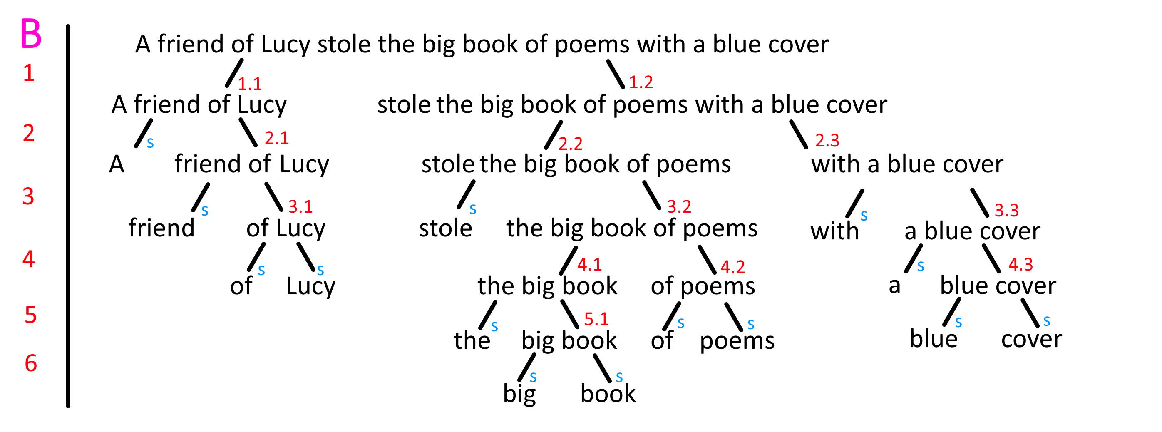
(b)
The sentence Frank drove the red car in the garage has two interpretations. In interpretation A, Frank drove the red car inside the garage, as in he never leaves the garage. In interpretation B, Frank drove the red car which was parked in the garage (the car is then driven out of the garage). The following are the binary phrase structure trees for both interpretations:

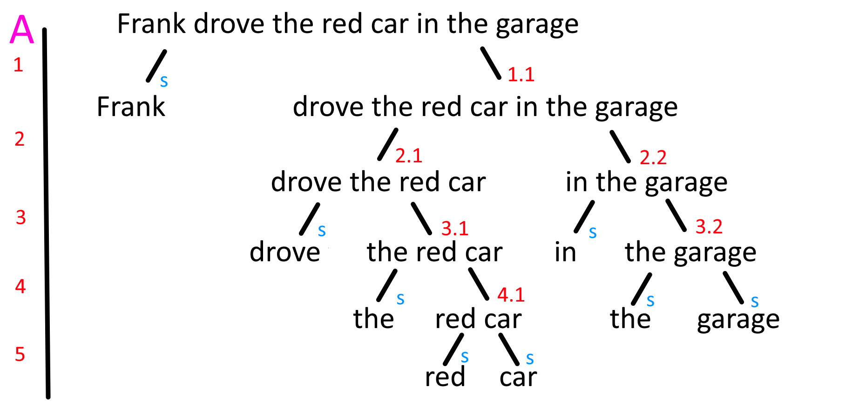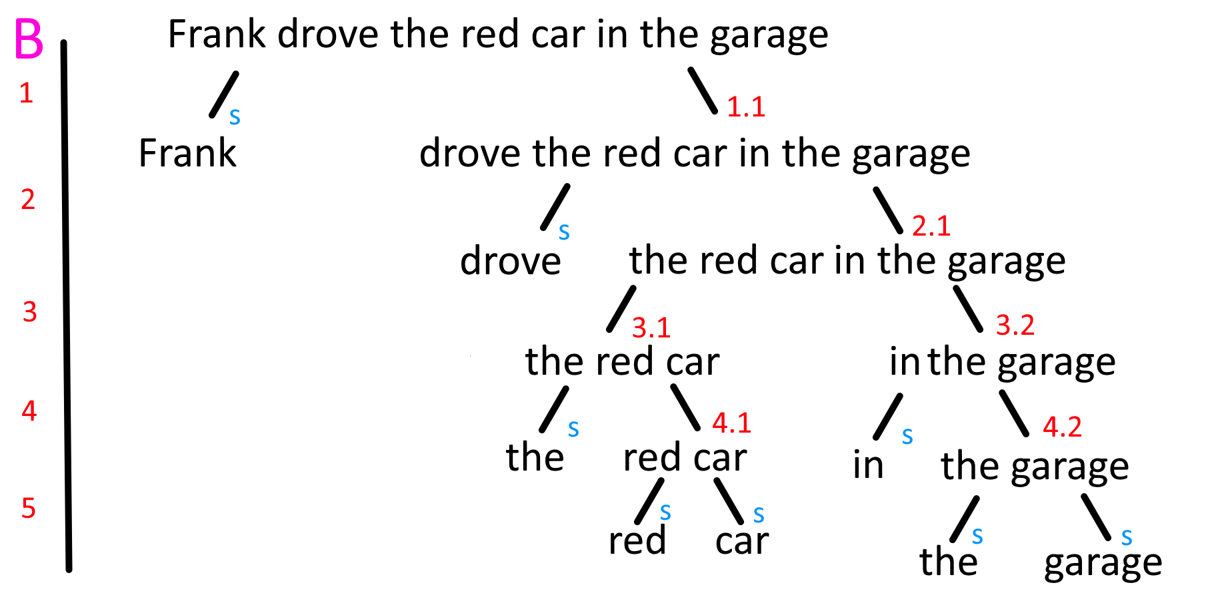
My best guess for where this goes wrong is with “the red car in the garage”. The following is my attempt to correct the tree:
Again, like with (a), I will list the changes here, since the indexes have now changed:
- One new connection has been added: 3.1) “red car in the garage” can be replaced with simpy “car”.
- The connection formerly noted as 3.1) no longer exists, since “the” was removed earlier.

(2)
The leaf-nodes, which by design are only one word, are uninteresting, since singular words are constituents regardless of context. The connections that lead to these nodes are marked with a blue s, to show that these will not be discussed. All other connections are marked with an index, which will be referred to when discussing the resulting node.

(a)
Firstly, we will look at interpretation A. Within this interpretation, “the blue cover” is a part of “the big book of poems” (as in, the book has a blue cover).

1.1: “A friend of Lucy” can be replaced with “they”. (replacement)
1.2: “stole the big book of poems with a blue cover” can be replaced with “did”. (replacement)
2.1: “friend of Lucy” can be coordinated with something like “and enemy of Andrew”. (coordination)
2.2: “the big book of poems with a blue cover” can be replaced with “it”. (replacement)
3.1: “of Lucy” can be coordinated with something like “and of Charles”. (coordination) (this one is admittedly on shaky ground)
3.2: “the big book of poems” is a suitable answer to the question “What did Lucy’s friend steal?” (stand-alone)
This incarnation of 3.2 no longer exists.
3.3: “with a blue cover” can be coordinated with something like “and with a golden lining”. (coordination) (like 3.1, this one is also somewhat shaky)
4.1: like with 3.2, “the big book” is a suitable answer to the question “What did Lucy’s friend steal?” (stand-alone)
4.1: We can rewrite this as “It was the big book that was of poems” (clefting) (I believe this may be an incorrect usage of the clefting test, since it usually rearranges the sentence causing the beginning to be at the end. In this case it simply splits the words apart, which I am not sure is allowed)
4.2: “of poems” can be coordinated with something like “and of hymns”. (coordination)
4.3: “a blue cover” can be coordinated with “and a black sigil” (coordination)
5.1: This node is admittedly difficult to obtain evidence for. If the sentence was “A friend of Lucy stole the big book”, without the rest of the sentence, “big book” could be replaced simply with “book”, which is some evidence for this being the correct split. I have, however, been completely unable to find evidence for “the big” being a constituent, which is why I chose this split.
5.2: “blue cover” can be coordinated with something like “and gilded pages”. (coordination)

Now we will look at interpretation B. Within this interpretation, “the blue cover” is used to steal the book of poems. (The nodes that are unchanged are not mentioned again here)

1.1: same as A 1.1
1.2: same as A 1.2
2.1: same as A 2.1
2.2: “the big book of poems” is a suitable answer to the question “What did Lucy’s friend steal?” (stand-alone)
2.3: “with a blue cover” can be moved: “it was with a blue cover that a friend of Lucy stole the big book of poems”. (movement
3.1: same as A 3.1
3.2: same as A 3.2
3.3: “a blue cover” can be coordinated with “and a black sigil” (coordination)
4.1: same as A 4.1
4.2: same as A 4.2
4.3: “blue cover” can be coordinated with something like “and gilded pages”. (coordination)
5.1: same as A 5.1

(b)
Again, we begin with interpretation A. Within this interpretation, the car is driven within the garage (as in the car never leaves the garage)

1.1: “drove the red car in the garage” can be replaced with “did”. (replacement)
2.1: “drove the red car” is a suitable response to the question “what did Frank do?” (stand-alone)
2.1: “drove the red car” can be coordinated with “and fixed the blue car”. (coordination)
2.2: “in the garage” can be moved: “it was in the garage that frank drove the red car”. (movement)
3.1: “the red car” can be coordinated with something like “and the blue car”.
3.2: “the garage” can be replaced with “there” (replacement)
4.1: This is the same situation as seen with “big book” earlier. If the sentence was “Frank drove the red car”, without the rest of the sentence, “red car” could be replaced simply with “car”, which is some evidence for this being the correct split. I have, however, been completely unable to find evidence for “the red” being a constituent, which is why I chose this split.

Now, let us look at interpretation B. Within this interpretation, the phrase “in the garage” simply refers to the car’s origin (as in Frank drove “the red car in the garage”, out of the garage). (Again, unchanged nodes are not mentioned again)

1.1: same as A 1.1
2.1: “the red car in the garage” can be replaced with “it”. (replacement)
3.1: same as A 3.1
This incarnation of 3.1 no longer exists.
3.2: “in the garage” can be moved: “it was in the garage that frank drove the red car”. (movement)
4.1: same as A 4.1
4.2: “the garage” can be replaced with “there” (replacement)

PROBLEM 3 (3 mark)

Assume that the domain consists of two individuals: {Annie, Bonnie}. For each of the sentences (a), (b), and (c), do the following.

(1) Identify and describe/display the binary phrase structure tree.

(2) Give the formal semantics of the sentence by assign appropriate denotations to the leaves and deriving compositionally the meanings of complex constituents.

(a) Annie met Bonnie.
(b) Annie runs and Bonnie walks.
(c) Someone walks.

ANSWER
(1)

(a)
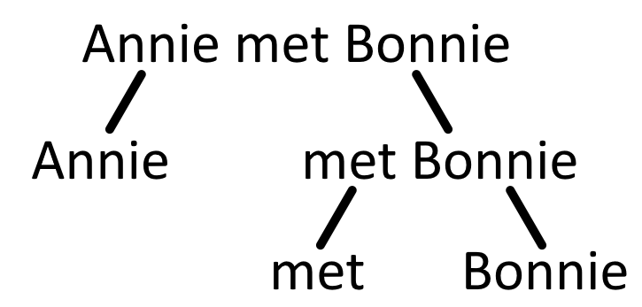
(b)
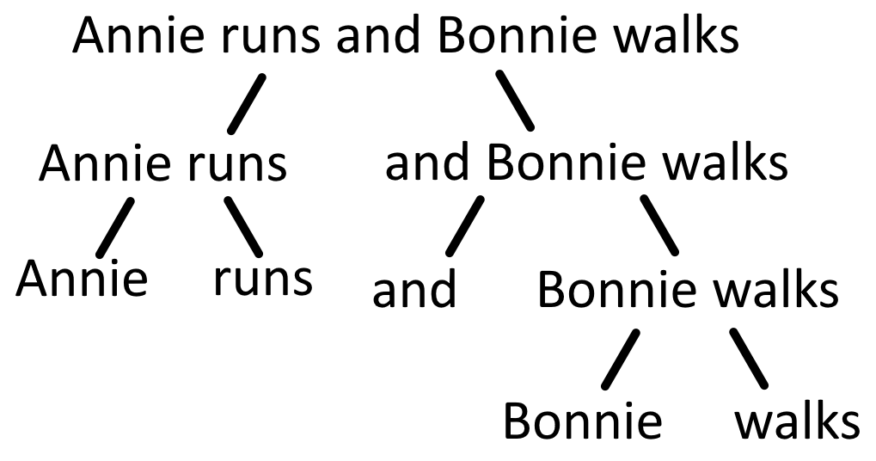
(c)
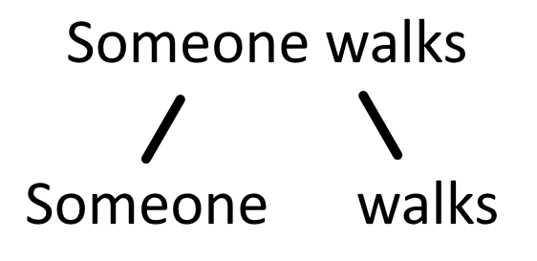

(2)

(a)
For (a), (b), and (c), we can notate the elements in out domain like this:
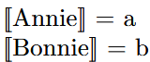
We also choose to represent truth values with 0 and 1, 0 being false, and 1 being true. When referencing functions within this text, they will be written in boldface.
For the first sentence, “Annie met Bonnie”, we assume that Annie has, in fact, met Bonnie, and therefore that Bonnie has also met Annie. We can then create the function met, like this:
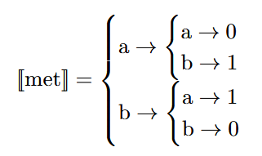
If we now attempt to evaluate the sentence, we first apply the function met to Bonnie, which returns a second function met Bonnie. We then apply this new function to Annie, which returns 1, giving us the truth value of the sentence:
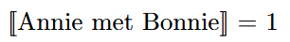

(b)

For the second sentence, “Annie runs and Bonnie walks”, let us assume that Annie is in fact running, Bonnie is in fact walking, and therefore that neither of them are performing the second activity. We define the functions runs and walks like this:
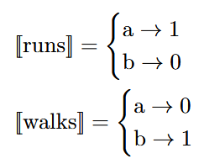
We now have denotations for all leaves except for and. Since “Bonnie walks” has a truth value, and must be a function that sends from truth values, and we define it like this:
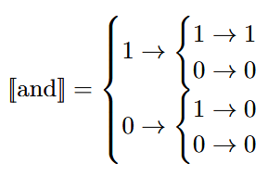
We can now evaluate the sentence. Applying walks to Bonnie gives us a truth value of 1. When we apply and to this 1, it returns the function and Bonnie walks sending 1 to 1, and 0 to 0. We then apply runs to Annie, which returns 1, and finally we apply and Bonnie walks to this 1, giving us the sentences truth value:

(c)

For the third sentence, “Someone walks”, we can reuse the function walks from the previous sentence, meaning we still assume that Bonnie is walking, but Annie is not. The remaining leaf we want to define a denotation for, is someone. Seeing how walks sends from our domain to truth values, and someone is not in the domain, someone cannot be the input for walks, which means it must be a function sending from functions to truth values. If we define notate our domain as D, we can define someone like this:
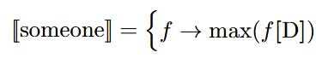
Where f is a function sending from D to truth values, and f[D] is the image of D through f. We can now evaluate the sentence. We apply someone to walks, giving us the maximum of the image of the domain D through walks. Looking at the definition of walks, we can see that walks[D] = {1,0}, and so the maximum of this is 1:
